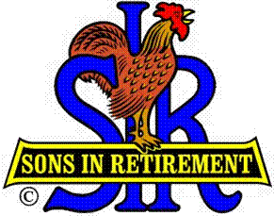
Las Trampas Branch 116
BEC Meeting Agenda
July 15, 2019, 9:30 AM
The Mission of SIR is to improve the lives of our members through fun activities and events – while making friends for life.

09:15 Coffee Available
09:30 Call to order; Secretary confirm a quorum
09:31 Secretary – Fred Schafer – Approval of June 17, 2019 minutes
09:33 Treasurer – Jim Nickels – Report, Missed Luncheon Receipts
09:37 Standing Reports
- Attendance – Jim Flessner – Attendance, Guests and Visitors
- Membership – Phil Goff – New Members to be inducted,
- Activities Chair – Fred Wachowicz
09:45 Big SIR Report – Jerry Hicks
1. State Convention August 20-21
2. Region Social – Tony de Lasada
3. RAMP Training - Rossmoor
09:50 Little SIR Report – Michael Barrington
1. Speaker: Tony Elkrington – Battle of the Atlantic -
10:02 Old Business
- Follow up Discussion on Membership
10:07 New Business:
- Present the Officer and Director slate in writing – Marty Katz
10:15 Other Discussion
1. Any inputs for State meeting in August 20.
10:20 Adjourn; Next BEC Meeting, August 19, 2019

